**REACT JAVASCRIPT**

* React is a js library and not a framework. It focuses on building the user interface
* 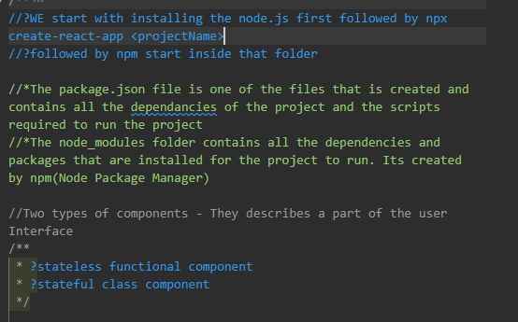

1. FUNCTIONAL COMPONENT

* To create one we first create a folder in the src folder and then followed by our component(basically a js file)
* 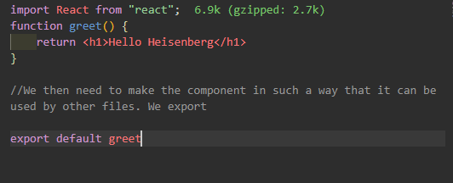
* It is advisable to write the functions with the ES6 arrow functions



* In the App.js file we import our new component and then use it as a html tag. If there is no content between the tag we can simply make it a self-closing tag

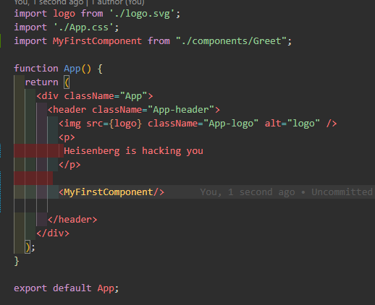

1. CLASS COMPONENTS

* The steps to follow when creating a class component is as follows;
  + - Create a js file
    - Import react, and a component of react
    - Declare a class that extends the component from react
    - Declare a render function that returns null or some html
    - Export the component, import in app.js and use it

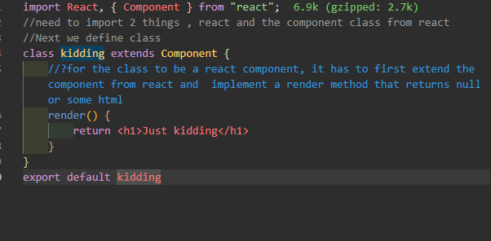

* So functional components are invoked like functions when used and have curly braces around them while class components are JS classes and should be used as JSX elements.

JSX – JAVASCRIPT XML

JSX stands for JavaScript XML. It is a syntax extension for JavaScript that allows you to write HTML-like elements and components in your JavaScript code.

So far we have written our components in jsx. The following component is written without JSX

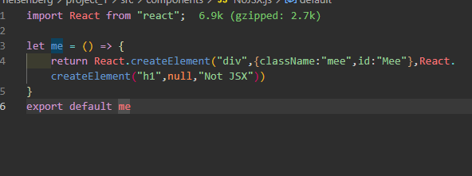

Notice how class changes to className. Why? Class is a reserved word in JS

* We can also include normal functions and js code inside the App.js file

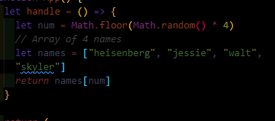



**STYLING OUR COMPONENTS**

1. Inline styling

* We a gonna use two curly braces. The second curly brace is going to take the styles like an object

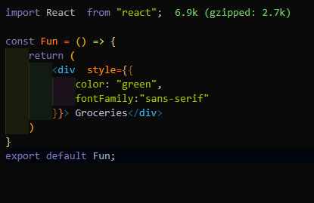

* We can as well create an object of styles and use it as follows:

